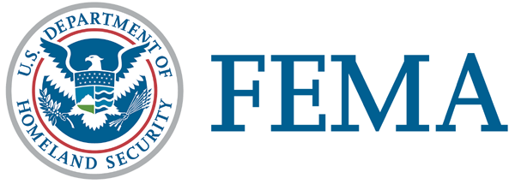
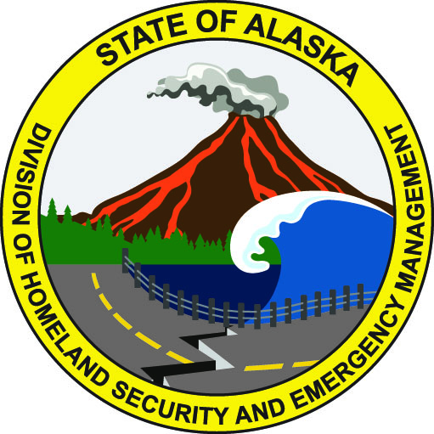
March 8, 2019
FEMA DR-4413-AK NR 018
FEMA News Desk: 907-227-0790
Alaska PIO: 907-428-7140
SBA PIO 916-847-2638

News Release

Workshops in Anchorage and Wasilla to Offer Repair, Rebuilding Advice

ANCHORAGE, Alaska – FEMA mitigation specialists will visit home improvement stores March 11-16 in Wasilla and the Municipality of Anchorage to provide advice on how to repair and rebuild structures safer and stronger, and general tips to help Alaskans prepare for the next earthquake.

The workshops will also offer home improvement tips and share proven methods to prevent or reduce damage from a disaster. Most of the information and free publications are aimed at general contractors and those willing to take on do-it-yourself projects.

A federal disaster was declared after the Nov. 30 Cook Inlet earthquake, making the state of Alaska eligible for FEMA’s Hazard Mitigation Grant Program. Mitigation specialists will cover such topics as securing/strapping/anchoring utilities and large appliances, and protecting your personal property from earthquake damage.

Workshop schedule:

Location | Time
Home Depot  400 Rodeo Place  Anchorage, AK 99508 | March 11-16: 9 a.m. to 7 p.m.
Home Depot  1715 Abbott Road  Anchorage, AK 99508 | March 11-16: 9 a.m. to 7 p.m.
Home Depot  1255 E. Palmer-Wasilla Hwy.  Wasilla, AK 99654 | March 11-16: 9 a.m. to 7 p.m.
Spenard Builders Supply  4412 Lois Dr.  Anchorage, AK 99517 | March 11-16: 8 a.m. to 5:30 p.m.

Rebuilding properly with the best technical guidance and using tested techniques will assure that homes are more resistant to disasters.

For more information on Alaska’s disaster recovery, visit FEMA.gov/disaster/4413, Twitter.com/FEMARegion10 and Facebook.com/FEMA.

# # #

FEMA's mission is helping people before, during, and after disasters.

Disaster recovery assistance is available without regard to race, color, religion, nationality, sex, age, disability, English proficiency or economic status. If you or someone you know has faced discrimination, call FEMA toll-free at 800-621-3362 (FEMA), voice/VP/711. Multilingual operators are available. TTY users may call 800-462-7585.

The U.S. Small Business Administration is the federal government’s primary source of money for the long-term rebuilding of disaster-damaged private property. SBA helps businesses of all sizes, private nonprofit organizations, homeowners and renters fund repairs or rebuilding efforts and cover the cost of replacing lost or disaster-damaged personal property. For more information, applicants may contact SBA’s Disaster Assistance Customer Service Center at 800-659-2955. TTY users may also call 800-877-8339. Applicants may also email DisasterCustomerService@sba.gov or visit SBA at www.SBA.gov/disaster .

