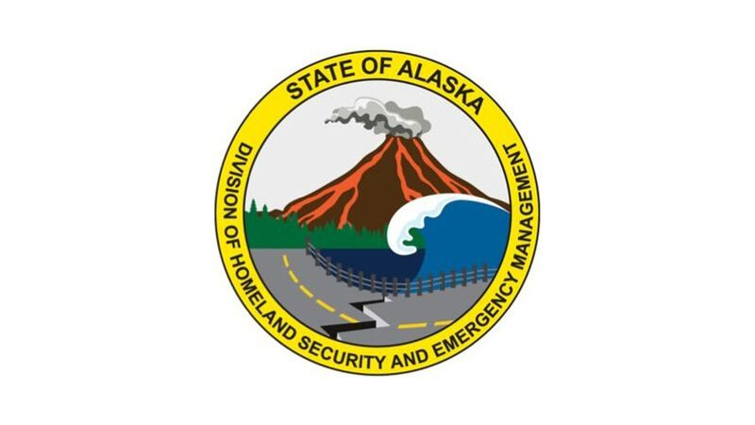
STATE OF ALASKA
Division of Homeland Security and Emergency Management
Building Resilient Infrastructure and Communities (BRIC) GRANT

QUARTERLY NARRATIVE PROGRESS REPORT

The grantor agency will use the information provided to monitor grantee performance and project implementation to ensure proper use of Federal funds. No further monies or other benefits may be paid under this program unless this report is completed and filed on time as required. The Narrative Progress Report must support the expenditures in the Financial Progress Report.
1. GRANTEE NAME AND ADDRESS |  |  | 2. STATE GRANT NUMBER |  |  | 3. REPORT NO.
<Jurisdiction>
<Address>
<City, State ZIP>
 |  |  | 4. REPORTING PERIOD (Dates)
  From: |  | To:
5. SHORT TITLE OF PROJECT: Use one form per program. Check the appropriate box above. |  |  |  | 6. GRANT AMOUNT | 7. TYPE OF REPORT
 |  |  |  | $0.00 | REGULAR  SPECIAL REQUEST
8. NAME AND TITLE OF PROJECT MANAGER |  | 9. SIGNATURE OF PROJECT MANAGER |  |  | 10. DATE OF REPORT
11. COMMENCE NARRATIVE REPORT HERE (Continue on plain paper and attach)
Mandatory reporting items:

1. Briefly describe significant activities and developments that have occurred that show performance during this quarter, including a comparison of actual accomplishments to the objectives in your sub-application:

2. Indicate whether completion of work is anticipated within the performance period. If not, describe any problems, delays, or adverse conditions that will impair the ability to meet the stated objectives in your sub-application:

3. Indicate whether cost under-run/cost over-run, change of scope request, or request for extension of performance period is anticipated:

4. Other pertinent information that relates to this grant or reporting period:

12. CERTIFICATION BY GRANTEE: I certify the activities conducted are aligned with the FEMA-approved State Standard Hazard Mitigation Plan goals and objectives and the project plan as stated in the Application and/or Scope of Work, comply with grant program guidelines, and have received DHS&EM pre-approval where required.  Signatory Official Signature |  |  |  |  | 13. DATE

INSTRUCTIONS FOR DOCUMENTATION AND COMPLETION OF QUARTERLY NARRATIVE PROGRESS REPORTS

Grantees are required to submit Quarterly Narrative Progress Reports on project activities and accomplishments as provided in the project Scope of Work. Progress reports shall compare actual accomplishments to the objectives established for the reporting period in the project timeline, report reasons for deviations, and justification for a timeline adjustment. Include any significant events or activities. The Quarterly Narrative Progress Report must support expenditures in the Quarterly Financial Progress Report. A Quarterly Narrative Progress Report is required whether or not any grant activities occurred during the period.

- Date Due. Reports are due every quarter as scheduled below for the performance period of the grant. Refer to the Obligating Award Document regarding “Reimbursements” and “Penalties for Non-Compliance” regarding delinquent reports.

Due No Later Than Reporting Period:
April 20 January 1 - March 31 July 20 April 1 - June 30
October 20 July 1 – September 30
January 20 October 1 – December 31

The Final Quarterly Narrative Progress Report for any multi-year grant is due 45 days following the close of the grant period.

- Submission. Submit the report with original signatures and supplemental documentation to mva.grants@alaska.gov.

3. Grant Administration and Project Management: For Grant Administration, contact mva.grants@alaska.gov or (907) 428-7000. For the Project Manager, contact Rai Simpliciano at rai.simpliciano@alaska.gov or (907) 428-7606.

4. Form and Execution. Grantees shall use this form as a face sheet. Use one form per report per grant program and check the appropriate box. Attach additional pages as needed. The Project Manager shall sign the Quarterly Narrative Progress Report and the Authorizing Official designated on the Obligating Award Document or any duly authorized successor or a specific person delegated in writing by the Authorizing Official. Signatures of two separate individuals are required on the Quarterly Narrative Report. Immediately advise DHS&EM of any changes to the signatory officials listed on the grant award. Personnel changes in signatory authority may require a grant award amendment.

5. Reporting Requirements. The reporting requirements are designed to provide the DHS&EM with sufficient information to monitor grant implementation, project implementation, and goal achievement in support of the FEMA-approved State Standard Mitigation Plan. Narrative Progress Reports must be performance-based and relate to the project Scope of Work or application narrative, correlating with goals, objectives, timelines, milestones, and accomplishments. Attach meeting agendas and minutes. Records shall be maintained for six years from the date of grant closeout.

