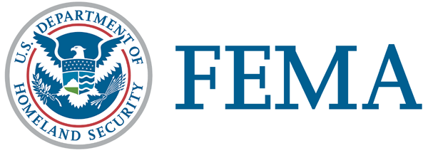
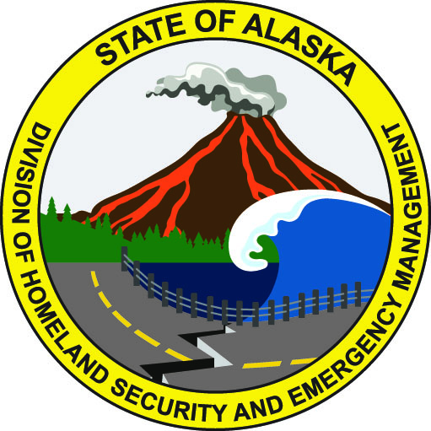
March 9, 2019
FEMA DR-4413-AK NR 019
FEMA News Desk: 907-227-0790
Alaska PIO: 907-428-7140
SBA PIO 916-847-2638

News Release

March 14 Deadline Nears for Alaskans to File for Disaster Unemployment Assistance

Alaska workers in the Municipality of Anchorage, Mat-Su Borough and Kenai Peninsula Borough whose source of income was affected by the Nov. 30 earthquake may be eligible for the state’s Disaster Unemployment Assistance program.

This program is designed for those who are self-employed or not otherwise eligible for regular unemployment assistance. Workers who are covered by the state of Alaska’s regular unemployment insurance would follow the standard unemployment insurance process.

Individuals may be eligible for up to 35 weeks of benefits beginning Dec. 2, 2018.

The Disaster Unemployment Assistance program is funded by the Federal Emergency Management Agency and disbursed by the State of Alaska Department of Labor and Workforce Development.

To apply, call: 888-252-2557 or 907-269-4700 Monday to Friday, 10 a.m. to 3 p.m. Applications must be submitted by March 14.

Applicants must provide:
- Social Security Number.
- Contact information for their most recent employer.
- Dates worked.
- Documentation of wages or self-employment earnings.

Individuals may qualify for disaster unemployment assistance if they:
- Became unemployed or unable to work as a direct result of the disaster.
- Have exhausted their regular unemployment insurance benefits.
- Worked or were self-employed, or were scheduled to begin work or self-employment, in the designated areas.
- Are unable to get to work as a direct result of the disaster.
- Are available and able to work, unless injured as a direct result of the disaster.
- Have not turned down an offer of employment in a comparable position.
- Can no longer work because of damage or destruction to their place of employment caused by the disaster.

For more information, contact:
Pam Frenette, Disaster Unemployment Assistance Coordinator
State of Alaska Department of Labor and Workforce Development
907-465-1152
Pamela.Frenette@alaska.gov

# # #

FEMA's mission is helping people before, during, and after disasters.

Disaster recovery assistance is available without regard to race, color, religion, nationality, sex, age, disability, English proficiency or economic status. If you or someone you know has faced discrimination, call FEMA toll-free at 800-621-3362 (FEMA), voice/VP/711. Multilingual operators are available. TTY users may call 800-462-7585.

The U.S. Small Business Administration is the federal government’s primary source of money for the long-term rebuilding of disaster-damaged private property. SBA helps businesses of all sizes, private nonprofit organizations, homeowners and renters fund repairs or rebuilding efforts and cover the cost of replacing lost or disaster-damaged personal property. For more information, applicants may contact SBA’s Disaster Assistance Customer Service Center at 800-659-2955. TTY users may also call 800-877-8339. Applicants may also email DisasterCustomerService@sba.gov or visit SBA at www.SBA.gov/disaster .

