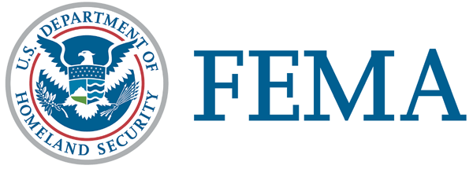
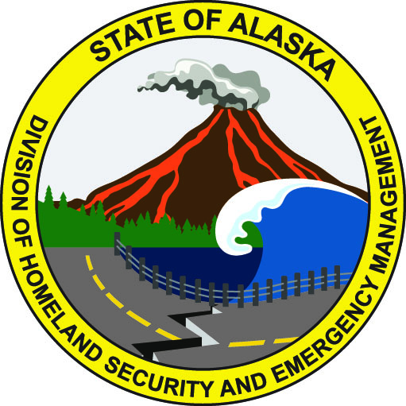
March 8, 2019
FEMA DR-4413-AK NR 017
FEMA News Desk: 907-227-0790
Alaska PIO: 907-428-7140
SBA PIO 916-847-2638

News Release

Help Remains After Soldotna Disaster Recovery Center Closes March 9

ANCHORAGE, Alaska – The Kenai Peninsula Borough disaster recovery center in Soldotna will close Saturday but help is still a phone call away.

The Soldotna center, located at the Soldotna United Methodist Church, 158 S. Binkley St., Soldotna, AK 99669, closes at 7 p.m. but residents can still file an application, get updates about their application, or learn about the appeals process by calling the helpline or visiting the disaster assistance website.

Here’s how:
- Call the helpline: 800-621-3362 (FEMA), voice/VP/711. Help is available in most languages. TTY users may call 800-462-7585. Hours are daily from 7 a.m. to 10 p.m.
- Visit DisasterAssistance.gov

After a disaster recovery center closes, residents who applied for disaster assistance are encouraged to stay in touch with FEMA. If applicants change addresses or phone numbers they should update FEMA with the information. Missing or incorrect information could result in delays in receiving assistance.

Alaska residents who have not yet applied for assistance have until April 1 to do so.

After registering with FEMA, businesses and residents can visit www.SBA.gov/disaster or contact SBA’s Disaster Assistance Customer Service Center at 800-659-2955 to apply for a low interest disaster loan or get information SBA’s programs. TTY users may also call 800-877-8339. Applicants may also email DisasterCustomerService@sba.gov.

Federal assistance is available to eligible individuals and households in the Municipality of Anchorage, Mat-Su Borough and Kenai Peninsula Borough.

For more information on Alaska’s disaster recovery, visit FEMA.gov/disaster/4413, twitter.com/FEMAregion10 and Facebook.com/FEMA.

# # #

FEMA's mission is helping people before, during, and after disasters.

Disaster recovery assistance is available without regard to race, color, religion, nationality, sex, age, disability, English proficiency or economic status. If you or someone you know has faced discrimination, call FEMA toll-free at 800-621-3362 (FEMA), voice/VP/711. Multilingual operators are available. TTY users may call 800-462-7585.

The U.S. Small Business Administration is the federal government’s primary source of money for the long-term rebuilding of disaster-damaged private property. SBA helps businesses of all sizes, private nonprofit organizations, homeowners and renters fund repairs or rebuilding efforts and cover the cost of replacing lost or disaster-damaged personal property. For more information, applicants may contact SBA’s Disaster Assistance Customer Service Center at 800-659-2955. TTY users may also call 800-877-8339. Applicants may also email DisasterCustomerService@sba.gov or visit SBA at www.SBA.gov/disaster .

