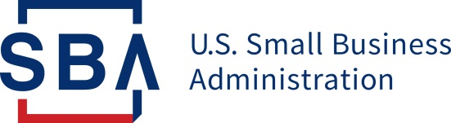
NEWS RELEASE

Disaster Field Operations Center West

Release Date: March 1, 2019 | Contact: Richard A. Jenkins, (916) 735-1500, Richard.Jenkins@sba.gov
Release Number: AK 15861-02 | Follow us on Twitter, Facebook, Blogs & Instagram

One Month Left to Apply for SBA Disaster Loans

SACRAMENTO, Calif. – Director Tanya N. Garfield of the U.S. Small Business Administration’s Disaster Field Operations Center-West today reminded Alaska private nonprofit organizations of the April 1, 2019, deadline to apply for an SBA federal disaster loan for property damage caused by the earthquake that occurred Nov.30, 2018. Private nonprofits that provide essential services of a governmental nature are eligible for assistance.

According to Garfield, eligible private nonprofits of any size may apply for SBA federal disaster loans of up to $2 million to repair or replace damaged or destroyed real estate, machinery and equipment, inventory and other business assets. SBA can also lend additional funds to help with the cost of making improvements that protect, prevent or minimize the same type of disaster damage from occurring in the future.

In addition, SBA offers Economic Injury Disaster Loans to help eligible private nonprofits meet working capital needs caused by the disaster. Economic Injury Disaster Loans may be used to pay fixed debts, payroll, accounts payable and other bills that cannot be paid because of the disaster’s impact. Economic injury assistance is available regardless of whether the private nonprofit suffered any property damage. Private nonprofits have until Oct.31, 2019, to apply for an SBA Economic Injury Disaster Loan.

These low-interest federal disaster loans are available in Kenai Peninsula Borough, Matanuska-Susitna Borough and the Municipality of Anchorage.

The interest rate is 2.75 percent with terms up to 30 years. Loan amounts and terms are set by SBA and based on each applicant’s financial condition.

Applicants may apply online, receive additional disaster assistance information and download applications at https://disasterloan.sba.gov/ela. Applicants may also call SBA’s Customer Service Center at (800) 659-2955 or email disastercustomerservice@sba.gov for more information on SBA disaster assistance. Individuals who are deaf or hard-of-hearing may call (800) 877-8339. Completed applications should be mailed to U.S. Small Business Administration, Processing and Disbursement Center, 14925 Kingsport Road, Fort Worth, TX 76155.

###

About the U.S. Small Business Administration
The U.S. Small Business Administration makes the American dream of business ownership a reality. As the only go-to resource and voice for small businesses backed by the strength of the federal government, the SBA empowers entrepreneurs and small business owners with the resources and support they need to start, grow or expand their businesses, or recover from a declared disaster. It delivers services through an extensive network of SBA field offices and partnerships with public and private organizations. To learn more, visit www.sba.gov.

