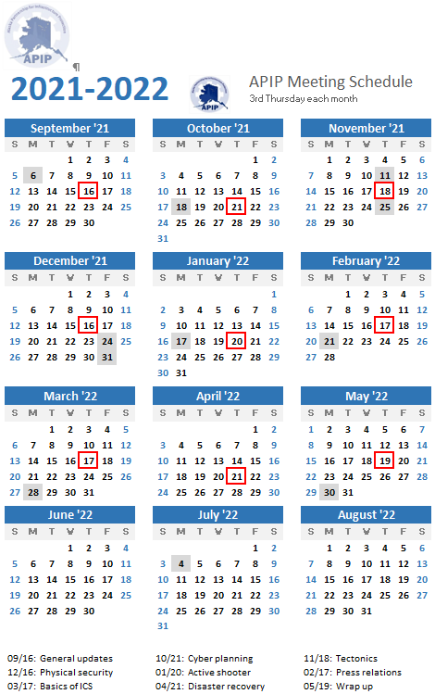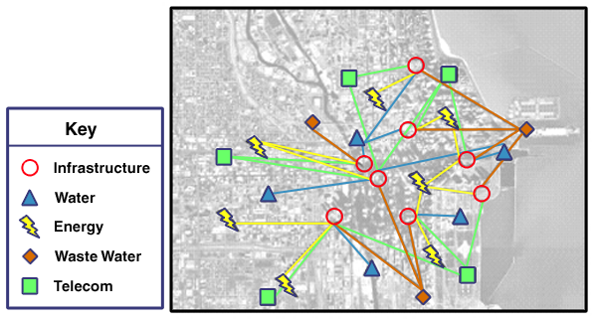

MEETINGS:

APIP has 9 monthly meetings per year

(September through May)

Meetings are hosted in Anchorage with an accessible teleconference line.

APIP is a public-private partnership established to better prepare critical infrastructure owners and operators to mitigate, respond to, and recover from a disaster.

**https://ready.alaska.gov/APIP**

For More Information Please Contact:

* Co-Chair State of Alaska Division of Homeland Security and Emergency Management:

Bob Carmichael

Bob.Carmichael@Alaska.gov

907.428.7020

* Co- Chair Private Sector, Alaska Communications (ACS):

Shawna Smith [Shawna.smith@acsalaska.com](mailto:Shawna.smith@acsalaska.com)

907.229.6300

### Why We Do what we do…

Because the private sector owns and operates a clear majority of Alaska's critical infrastructure, partnerships between the public and private sectors that foster integrated, collaborative engagement and interaction are essential to maintaining critical infrastructure security and resilience.

APIP improves Alaska’s emergency management capabilities through:

• Resource identification, sharing, and management.

• Information sharing, and management.

• Strengthening individual business’s response capacity.

• Understanding and addressing vulnerabilities, dependencies, and single points of failure.

• Team building and partnering for exercises.

**Alaska Partnership for Infrastructure Protection**

**APIP**

**APIP**

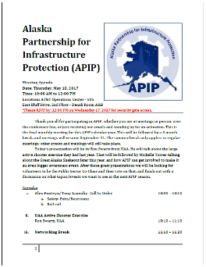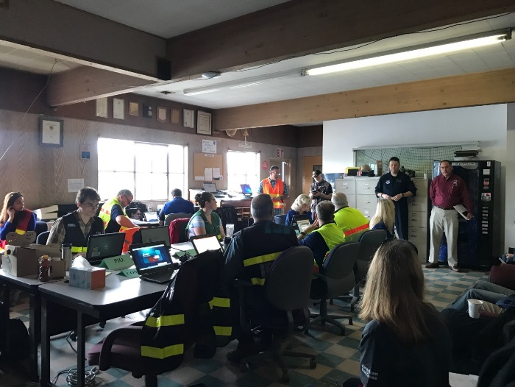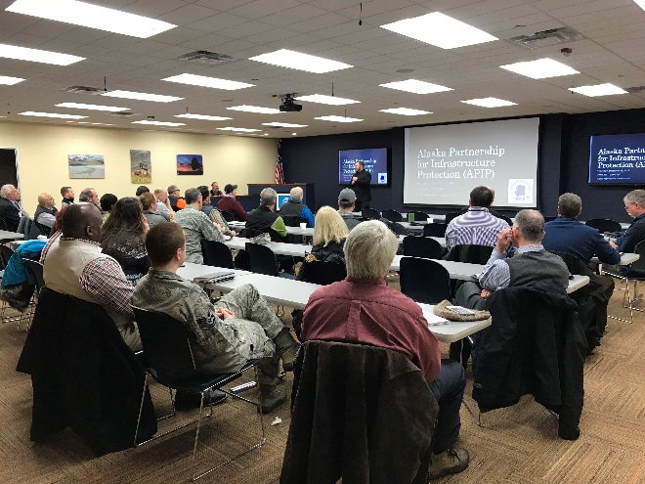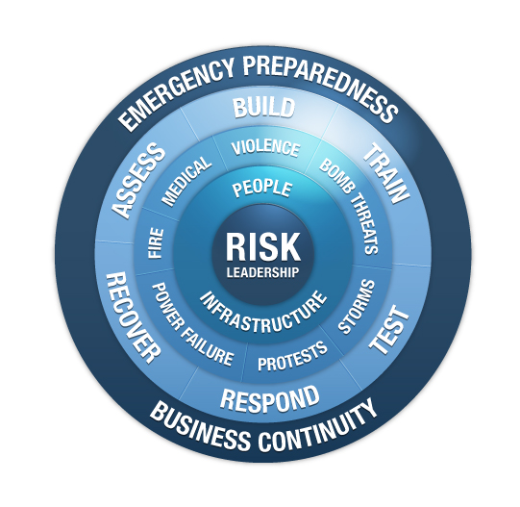

* Contact an APIP Co-Chair and request membership
* Members may volunteer to give presentations at monthly meetings

MEMBERSHIP:

* APIP Membership is open to critical infrastructure owners/operators/ administrators, those with governance over the infrastructure/ sector, and disaster response entities. Entities that exist to support other agencies with above roles may also be considered.

APIP IN PREPAREDNESS:

* Learn about other sectors and businesses
* Monthly meetings with presentations
* Participate in trainings, webinars, and exercises

APIP IN RESPONSE:

* Coordinate resource prioritization and allocation
* Provide situation reports
* Participate in teleconferences and other information sharing platforms

COORDINATION AND COLLABORATION

CRITICAL INFRASTRUCTURE

The U.S. Department of Homeland Security recognizes these 16 Critical Infrastructure Sectors as vital to public confidence and the Nation's safety, prosperity, and well-being:

• Chemical Sector

• Commercial Facilities Sector

• Communications Sector

• Critical Manufacturing Sector

• Dams Sector

• Defense Industrial Base Sector

• Emergency Services Sector

• Energy Sector

• Financial Services Sector

• Food and Agriculture Sector

• Government Facilities Sector

• Healthcare and Public Health Sector

• Information Technology Sector

• Nuclear Reactors, Materials, and Waste Sector

• Sector-Specific Agencies

• Transportation Systems Sector

• Water and Wastewater Systems Sector