Alaska Partnership for Infrastructure Protection
Overview for 2021-2022 Season

Goals and Objectives
The main goal of this season is to support resiliency planning for critical infrastructure members.
The objectives for this season are to:
- List, evaluate, and communicate sector-related risks to continuity;
- Communicate risk control options; and
- Facilitate, where appropriate, intra-sector information and resource sharing.

Federal Department of Homeland Security’s Sixteen Critical Infrastructure Sectors
The following list will be used to group members by similar risks:

- Chemical
- Commercial
- Communications
- Critical Manufacturing
- Dams
- Defense Industrial Base
- Emergency Services
- Energy
- Financial
- Food and Agriculture
- Government Facilities
- Health and Public Health
- Information Technology
- Nuclear Reactors, Materials, and Waste
- Transportation
- Water and Wastewater Systems
Some members may operate in more than one sector. Members may choose which sector best suits their risks and may select more than one category. The intent is to deliver information that is useful without loading up an inbox with information that is not needed.

APIP Meeting Outline
APIP will meet every third Thursday of the month, from 1000 hours to 1200 hours. The format may be in-person or virtual, depending on circumstances.
Meetings will follow a basic format consisting of:
1000-Meeting Commencement
1000-1015 Previous Meeting Re-Cap and Threat Update
1015-1045 Presentations, Training, or Workshops
1045-1100 Break
1100-1145 Presentations, Training, or Workshops
1145-1200 APIP Old and New Business
1200 – Meeting Adjournment
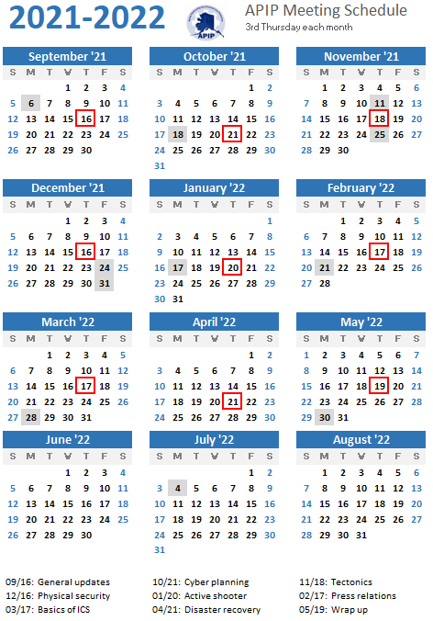

APIP Meeting Agendas (DRAFT)

16 September 2021 - Welcome Back and Way Ahead (format: virtual)
- APIP Season Kick-off – Shawna Watson and Bob Carmichael
- Season Goals – APIP Round-Table Discussion, member feedback and suggestions
- APIP Charter Update – Shawna Watson and Bob Carmichael
- Alaska Response Annex Revisions – Kevin Reeve, DHS&EM
21 October 2021 – Cyber Security Planning (format TBD)
- Risks
- Protection
- Recovery
- Resources List

18 November 2021 – Earthquakes, Volcanoes and other earth events (format TBD)
- Risks
- Protection
- Recovery
- Resources List

16 December 2021 – Physical Security and Vandalism (format TBD)
- Risks
- Protection
- Recovery
- Resources List

20 January 2022 – Active Shooter (format TBD)
- Risks
- Protection
- Recovery
- Resources List

17 February 2022 – Public Information and the Press (format TBD)
- Risks
- Protection
- Recovery
Resources List

17 March 2022 – Incident Command – Basics of ICS (format TBD)
- Risks
- Protection
- Recovery
- Resources List

21 April 2022 – Employee Training for Disaster & Recovery (format TBD)
- Risks
- Protection
- Recovery
- Resources List

19 May 2022 – AAR, Wrap-up and Plan for Next Season (format TBD)
- 2021 - 2022 Season After Action Review
- 2022 - 2023 Season Plan

FEMA Region X Alaska Response Annex Revisions

FEMA Region X has begun work on revising their Response Annex for a catastrophic disaster in Alaska. The revisions will be conducted over the space of 6-8 months, and may benefit from input from APIP member organizations who provide essential services or maintain critical infrastructure. The working groups meetings will take place outside of normal APIP meetings, but discussions and invitations to participate in the revision process will be routed through the APIP distribution network.

